Lab Tasks:

This lab task is to be done in Microsoft Word and then uploaded as a word file or pdf (pdf is

preferred).

(Q1) Explain how will you send a file size more than 25mb. Write steps and post screenshots of steps in your Lab report document.

(Q2) Explain briefly how webpages are designed and made, what kind of code is involved?

Introduction to Internet Basics (Terminologies, Websites etc.)

**LAB #06**



**Spring 2020**

**CSE102L Computer Programming Lab**

Submitted by: **Maaz Habib**

Registration No.: **273**

Class Section: **C**

“On my honor, as student of University of Engineering and Technology, I have neither given nor received unauthorized assistance on this academic work.”

Student Signature: ______________

Submitted to:

**Engr. Abdullah Hamid**

January 14,2021

Department of Computer System Engineering

university of Engineering and Technology, Peshawar

(Q1) Explain how will you send file size more than 25mb. Write steps and post screenshots of steps in your Lab report document.

**Ans:**

1. Open the Gmail from which you have to send email. Then click compose to create an email, As marked below:

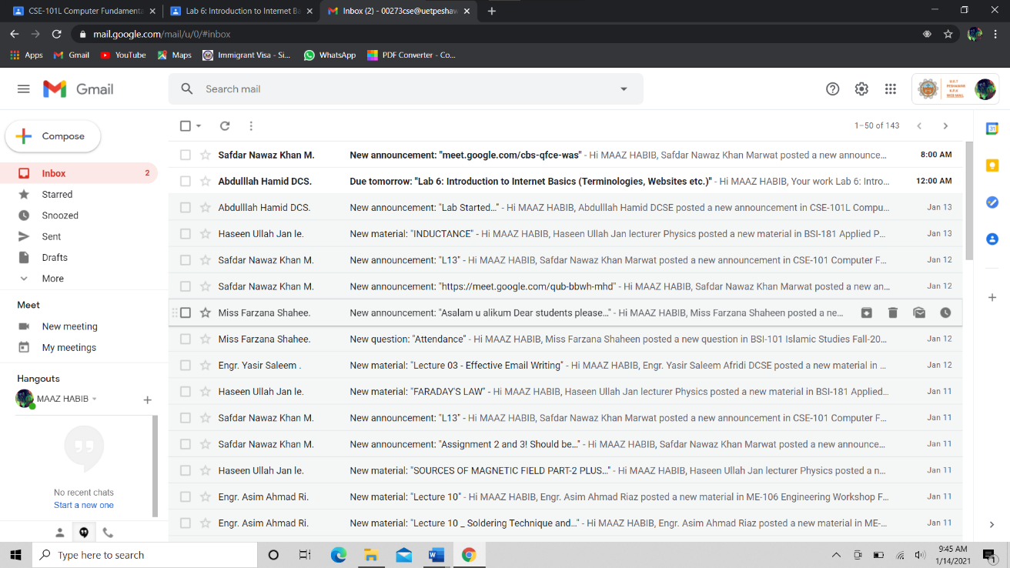

2. Then after clicking on compose, small window pops-up (as shown below). After that click on google drive icon, which is in a triangle shape.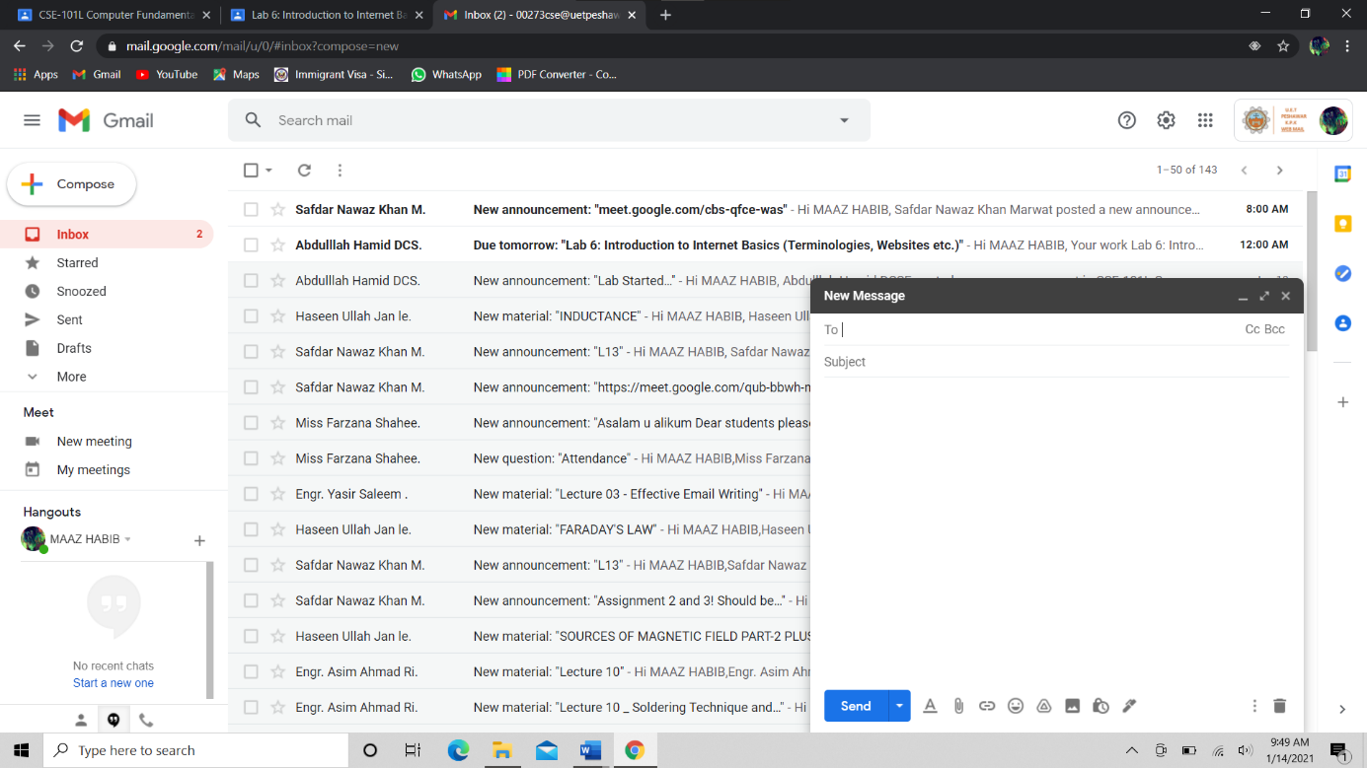

3.when u click on google drive icon a window pops-up, click upload as shown below:

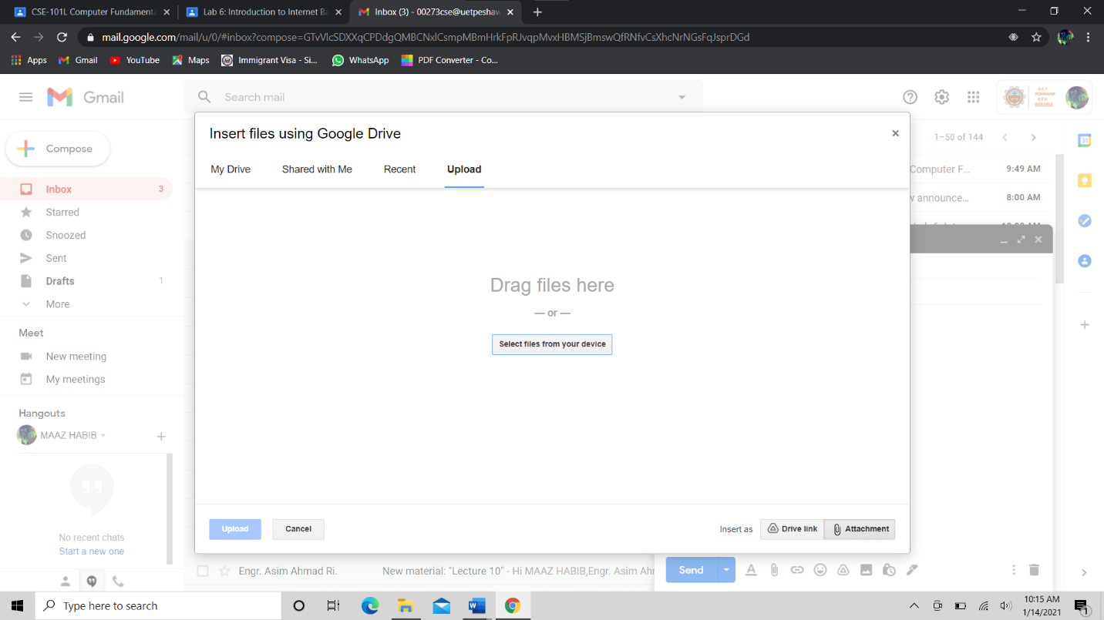

4. After selecting upload, click on select files from device or drag files here.

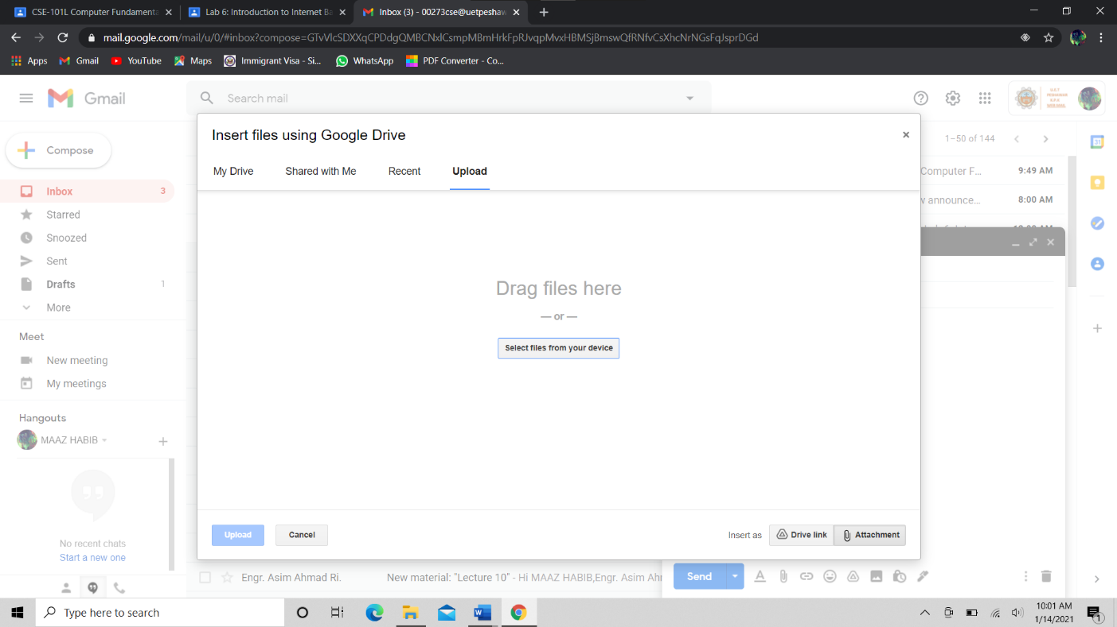

1. When you click on “select from this device” a window pops-up (as shown below), click on any file as u required which is more than 25mb, and then click open.

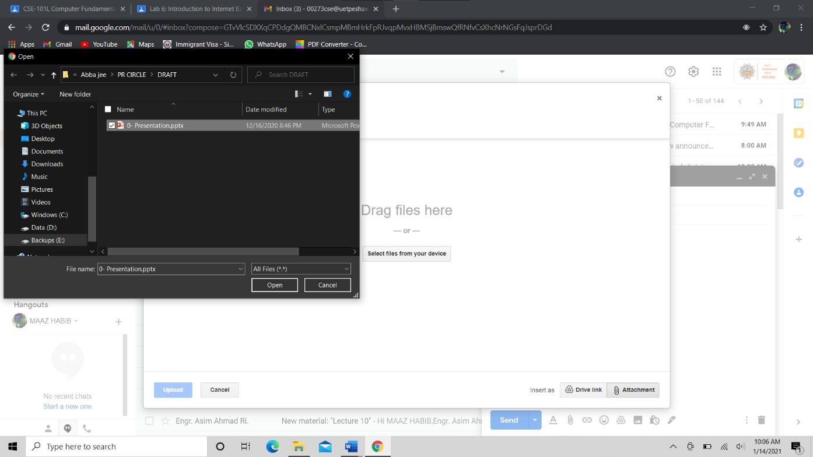

1. Browse the file location and open the file which you want to send. Then click upload as shown below.

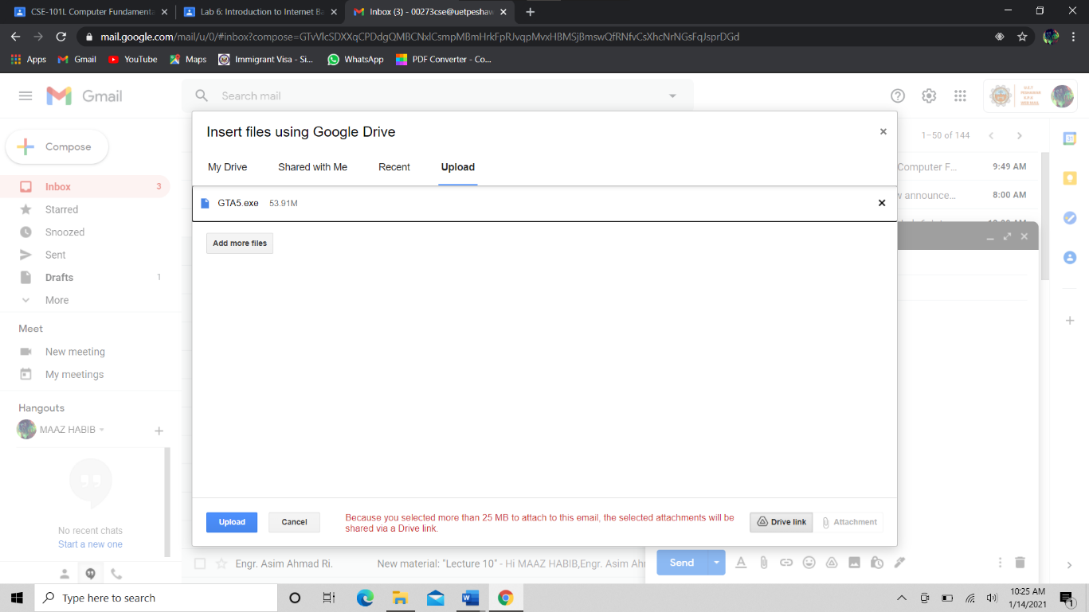

Note that the file is more than 25mb so it will send it as drive link as shown in the screen short above

1. After clicking upload the file will start to upload, you can check the progress as shown in the marked bar.

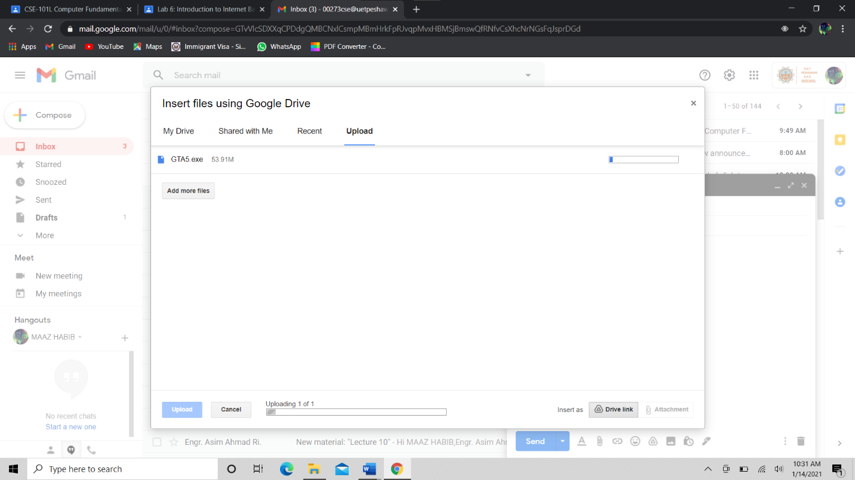

1. At last when the file is full uploaded or the bar is full , then windows will look like this, click on send and type all the details to whom you want to send it to.

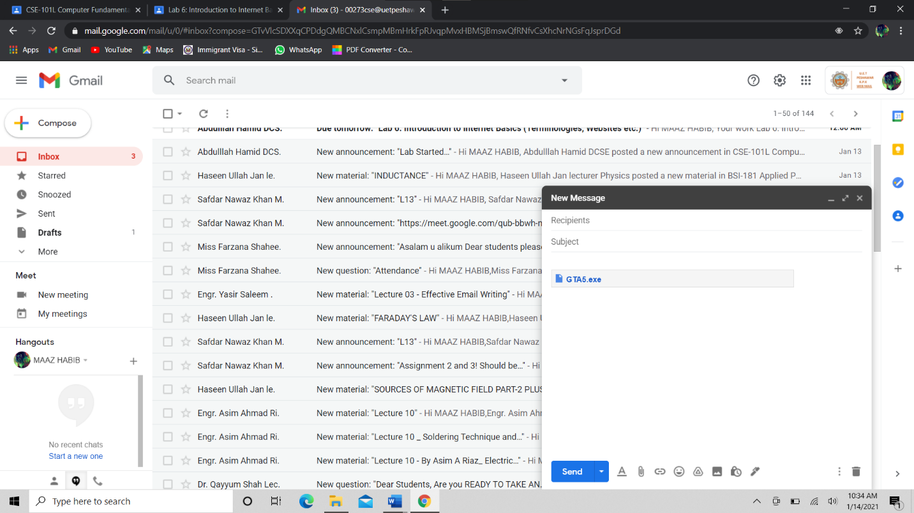

(Q2): Explain briefly how webpages are designed and made, what kind of code is involved?

**Ans:** Every web page is different. However, most pages contain the same elements as others. Below is an overview of the major elements of a web page.

1. The website name, domain name, or company name is often in the top-left corner of each web page.
2. There is also a [search](https://www.computerhope.com/jargon/s/search.htm) bar, that allows the visitor to search the website for related information and search what they need.
3. Also, we can find domain names from many websites like, GoDaddy etc.
4. The navigation bar, or menu for a web page, is often found on the top or left side of each web page. It should include links to each of the major sections of the website.
5. The heading should be included on the top of every web page and should be created using the [<h1>](https://www.computerhope.com/jargon/h/html-heading-tag.htm) HTML tag.
6. The opening paragraph is one of the most important paragraphs on the web page and should help draw the visitor into reading the web page.
7. Each web page should be broken up into other headings that allow the visitor to easily skim and find what is most interesting on the page. When creating a web page these can be done using the <h2> to <h6> HTML tags.
8. Having a method of allowing a visitor to provide feedback is also a requirement for most web pages. Giving the visitor links or buttons to click for feedback is a good step to let you know if a web page is helpful or not.
9. Additional information and tools such as a button to print the page can also be helpful for users on most web pages.
10. The footer should include any other important company or website information and be included on all web pages to help the visitor continue using the site.
11. The [Copyright](https://www.computerhope.com/jargon/c/copyrigh.htm) and any legal or privacy notice should also be on all web pages. Not only can this link to relevant legal information it is an indication for most visitors that they have reached the end of the web page.
12. Finally, a "back to the top" button or link at the bottom of the page helps the visitor return to the menu links or other tools.

**Basically, there are three part in it:**

* First is coding, and it can be done in many languages of computer like;
* HTML
* JAVA
* PYTHON and many more.
* As it is mention in step 5 and 7 above.
* The second part is hosting, which means deploying your website on a server so others can easily access your page.
* The last one is getting a domain name, which helps other to access it. As no one can learn IP addresses of all the sites, it is placed with the IP address for the visitors of the site. So, it is really important to have a domain name. It can be bought from places like GoDaddy etc.